INTERACTIVE PKU BULLETIN BOARD
“NewsNow”

EMIR HARRIS BIN M ZAINUDIN
Diploma in Computer Science
UNIVERSITI MALAYSIA PAHANG
AL-SULTAN ABDULLAH
UNIVERSITI MALAYSIA PAHANG AL-SULTAN ABDULLAH
DECLARATION OF THESIS AND COPYRIGHT

Author’s Full Name | : | EMIR HARRIS BIN M ZAINUDIN
Date of Birth | : | 6 NOVEMBER 2006
Title | : | INTERACTIVE PKU BULLETIN BOARD
Academic Session | : | 2025/2026

I declare that this thesis is classified as:

☐ | CONFIDENTIAL | (Contains confidential information under the Official Secret Act 1997)*
☐ | RESTRICTED | (Contains restricted information as specified by the organization where research was done)*
☐ | OPEN ACCESS | I agree that my thesis to be published as online open access (Full Text)

I acknowledge that Universiti Malaysia Pahang Al-Sultan Abdullah reserves the following
rights:

1. The Thesis is the Property of Universiti Malaysia Pahang Al-Sultan Abdullah
2. The Library of Universiti Malaysia Pahang Al-Sultan Abdullah has the right to make copies of the thesis for the purpose of research only.
3. The Library has the right to make copies of the thesis for academic exchange.

Certified by:

_________  (Student’s Signature)  ____061106101459____  New IC/Passport Number  Date: | _______________________  (Supervisor’s Signature)  _NORAZIAH BINTI AHMAD_  Name of Supervisor  Date:

NOTE : * If the thesis is CONFIDENTIAL or RESTRICTED, please attach a thesis declaration letter.


SUPERVISOR’s DECLARATION
I/We* hereby declare that I/We* have checked this thesis/project* and in my/our* opinion, this thesis/project* is adequate in terms of scope and quality for the award of the degree of *Doctor of Philosophy/ Master of Science.

_______________________________
(Supervisor’s Signature)
Full Name : NORAZIAH BINTI AHMAD
Position :
Date :

_______________________________
(Co-supervisor’s Signature)
Full Name :
Position :
Date :
STUDENT’S DECLARATION
I hereby declare that the work in this thesis is based on my original work except for quotations and citations which have been duly acknowledged. I also declare that it has not been previously or concurrently submitted for any other degree at Universiti Malaysia Pahang Al-Sultan Abdullah or any other institutions.


_______________________________
(Student’s Signature)
Full Name : EMIR HARRIS BIN M ZAINUDIN
ID Number : RC24201
Date : 1 October 2025

INTERACTIVE PKU BULLETIN BOARD
“NewsNow”

EMIR HARRIS BIN M ZAINUDIN
Thesis submitted in fulfillment of the requirements
for the award of the degree of
Diploma in Computer Science
Faculty of Computing
UNIVERSITI MALAYSIA PAHANG AL-SULTAN ABDULLAH
OCTOBER 2025

ACKNOWLEDGEMENTS
The Interactive PKU Bulletin Board, “News Now” project was designed and implemented to provide a visually appealing, accessible, and informative communication platform for the university community. The layout, colour scheme, and content highlights were carefully structured to ensure maximum readability, immediate engagement, and intuitive navigation of critical health information.
Key design components, such as thematic sections, clear headings, infographic panels, and strategically placed calls to action, were developed to facilitate the general theme of promoting proactive health and well-being. These components align with the centre's clean, trustworthy, and supportive identity. The project relied heavily on principles of effective visual communication and health literacy to ensure the messages—covering topics such as mental health resources, immunization schedule, and general wellness tips—are understandable and actionable for all students and staff.
Custom-designed visuals and organized content structure were utilized to maintain clarity and consistency throughout the board's entire display area. Throughout the conceptual and design process, various layout alternatives and material presentations were explored to optimize the display's impact and coordinate the intended educational character. The bulletin board successfully integrates dynamic content slots to ensure up-to-date announcements and real-time event promotions, thereby enhancing its relevance and functional utility.

ABSTRAK
Projek ini melibatkan pembangunan sebuah platform papan kenyataan dalam talian untuk Pusat Kesihatan Universiti (PKU) yang bertujuan memudahkan penyebaran maklumat kesihatan umum dan perkhidmatan klinik secara lebih sistematik dan berpusat. Dalam era digital masa kini, pelajar universiti sering berdepan dengan kesukaran untuk mendapatkan maklumat kesihatan yang tepat, terkini, dan boleh dipercayai disebabkan oleh penyebaran maklumat yang tidak tersusun serta bergantung kepada pelbagai saluran yang berbeza. Keadaan ini boleh menjejaskan tahap kesedaran kesihatan dalam kalangan pelajar serta mengurangkan keberkesanan penyampaian maklumat oleh pihak PKU.
Sehubungan itu, pembangunan laman web ini bertujuan untuk merapatkan jurang komunikasi antara pihak PKU dan pelajar dengan menyediakan satu platform yang pintar, interaktif, dan mesra pengguna. Sistem ini direka untuk membolehkan pelajar mengakses pengumuman kesihatan, jadual acara, kempen kesedaran, serta maklumat berkaitan waktu operasi klinik dengan lebih mudah dan pantas. Selain itu, platform ini juga memberi penekanan terhadap pengalaman pengguna (user experience) yang lebih baik melalui susun atur yang teratur, navigasi yang jelas, dan kandungan yang relevan dengan keperluan pengguna.
Dari sudut teknikal, kerangka kerja sistem ini dibangunkan menggunakan teknologi pembangunan web seperti HTML, CSS, dan JavaScript bagi memastikan kebolehaksesan yang tinggi serta keserasian merentas pelbagai peranti. Tambahan pula, sistem ini menyediakan fungsi pentadbiran yang membolehkan kakitangan PKU mengurus, mengemaskini, dan menerbitkan siaran dengan lebih cekap. Pada masa yang sama, pengguna akhir iaitu pelajar dapat menerima maklumat kesihatan dan pengumuman yang disesuaikan mengikut keperluan mereka.
Secara keseluruhannya, pembangunan platform ini dijangka dapat meningkatkan keberkesanan penyampaian maklumat kesihatan, menggalakkan kesedaran dalam kalangan pelajar, serta menyokong usaha PKU dalam menyediakan perkhidmatan kesihatan yang lebih efisien dan responsif kepada komuniti universiti.

ABSTRACT
This project involves the development of an online bulletin board platform for the University Health Centre (PKU) aimed at facilitating the dissemination of general health information and clinic-related services in a more systematic and centralized manner. In today’s digital era, university students often face challenges in accessing accurate, up-to-date, and reliable health information due to the fragmented nature of information across multiple channels. This situation can negatively impact health awareness among students and reduce the effectiveness of information delivery by the PKU.
Therefore, the development of this website aims to bridge the communication gap between the PKU and students by providing a smart, interactive, and user-friendly platform. The system is designed to enable students to easily and quickly access health announcements, event schedules, awareness campaigns, and information regarding clinic operating hours. In addition, the platform emphasizes an improved user experience through a well-structured layout, clear navigation, and content tailored to users’ needs.
From a technical perspective, the system framework is developed using web technologies such as HTML, CSS, and JavaScript to ensure high accessibility and cross-device compatibility. Furthermore, the system provides administrative functionalities that allow PKU staff to efficiently manage, update, and publish announcements. At the same time, end users, namely students, are able to receive health information and announcements that are tailored to their needs.
Overall, the development of this platform is expected to enhance the effectiveness of health information dissemination, promote health awareness among students, and support the PKU in delivering more efficient and responsive healthcare services to the university community.

TABLE OF CONTENT
DECLARATION
TITLE PAGE
ACKNOWLEDGEMENTS ii
ABSTRAK iii
ABSTRACT iv
TABLE OF CONTENT v
LIST OF TABLES viii
LIST OF FIGURES ix
LIST OF ABBREVIATIONS x
LIST OF APPENDICES xi
CHAPTER 1 INTRODUCTION 12
1.1 Background of Study 12
1.2 Problem Statement 13
1.3 Objective 13
1.4 Project Scope 13
1.5 Thesis Organization 14
CHAPTER 2 LITERATURE REVIEW 15
2.1 Introduction 15
2.2 Three Existing Systems 15
2.3 Requirement Elicitation 16
2.4 Comparison Among Existing Systems 16
2.5 Summary 17
CHAPTER 3 METHODOLOGY 18
3.1 Introduction 18
3.2 Software Process 19
3.2.1 Software Development Life Cycle (SDLC) 19
3.2.2 Gantt Chart 21
3.3 Project Requirement 21
3.3.1 Functional Requirement 21
3.3.2 Non-Functional Requirement 21
3.3.3 General Flow Chart 22
3.3.4 General Use Case Diagram 23
3.3.5 Context Diagram (DFD Level 0) 24
3.3.6 DFD Level 1 25
3.4 Proposed Design 26
3.4.1 Class Diagram 26
3.5 Data Design 27
3.5.1 ERD 27
3.6 Proof of Concepts 28
3.7 Testing Plan 33
CHAPTER 4 RESULTS AND DISCUSSION 35
4.1 Introduction 35
4.2 Table 35
CHAPTER 5 CONCLUSION 37
5.1 Introduction 37
REFERENCE 38
APPENDICES 40

LIST OF TABLES
Table 1.1 RAD Advantages 20

LIST OF FIGURES
Figure 1.1 RAD 22
Figure 1.2 Gantt Chart 24
Figure 1.3 Flowchart 25
Figure 1.4 Use Case Diagram 26
Figure 1.5 Context Diagram 27
Figure 1.6 DFD Level 1 28
Figure 3.1 Interviewing PKU Staff 1 29
Figure 3.2 Finish Interviewing PKU Staff 1 29
Figure 3.3 Interviewing PKU Staff 2 30
Figure 3.4 Finished Interviewing PKU Staff 2 30
Figure 1.7 Class Diagram 31
Figure 1.8 Entity Relationship Diagram 32

LIST OF ABBREVIATIONS
PKU | Pusat Kesihatan Umum
RAD | Rapid Application Development

LIST OF APPENDICES
No table of figures entries found.

INTRODUCTION

Background of Study
In today’s educational environment, effective communication of health-related information is crucial to supporting the well-being of university students and staff. At Universiti Malaysia Pahang Al-Sultan Abdullah (UMPSA), health announcements, clinic schedules, and wellness resources are primarily disseminated through traditional methods such as physical bulletin boards, static PDF documents, and irregular social media updates. While these methods have been historically functional, they are increasingly inadequate in meeting the needs of a tech-savvy, mobile-oriented academic community. The absence of a centralized, dynamic, and interactive digital platform leads to fragmented information flow, reduced accessibility, and missed critical updates—such as vaccination drives, mental health campaigns, or changes in clinic operating hours.
This project is motivated by the growing necessity to modernize health communication within university settings, aligning with global trends toward digital transformation in public health dissemination. The research aims to design and implement a dedicated online bulletin board system—termed “NewsNow”—that serves as a unified, real-time communication channel between the Pusat Kesihatan Umum (PKU) and the university community. By leveraging contemporary web technologies, the system seeks to enhance health literacy, promote proactive wellness behaviours, and streamline administrative workflows, thereby fostering a more informed and healthier campus environment.

Problem Statement
Effective communication between healthcare providers and the public is essential to ensure that important announcements, health campaigns, operational updates, and public health information are delivered promptly and efficiently. Currently, the PKU (Pusat Kesihatan Umum) spread announcements and bulletin information through various unofficial and platforms such as Instagram, Facebook, and sections of its official website.
However, relying on social media platforms presents several challenges. Important announcements can easily be missed due to social media algorithms, information overload, or users not actively following PKU's accounts. Furthermore, the information is scattered across multiple channels, making it difficult for users to locate and access relevant updates consistently.
Although PKU maintains an official website, bulletin and announcement information is often embedded within pages that are not prominently displayed or easily accessible to the public. As a result, users may experience difficulties finding important information, leading to reduced awareness of healthcare services, events, operational changes, and public health notices.
The absence of a centralized and dedicated bulletin board system limits the effectiveness of information dissemination and may negatively impact communication between PKU and the UMPSA community. Therefore, there is a need to develop a web-based PKU Bulletin Board System that consolidates announcements and notices into a single, accessible platform. Such a system would improve information visibility, enhance public accessibility, and ensure that important updates are communicated more effectively to all users.

Objective

To investigate and document the specific needs of PKU staff and UMP students regarding centralized health announcement features and content.

To design and develop a user-friendly, cross-platform web application for a PKU Health Bulletin Board that allows authenticated PKU staff to publish and manage announcements efficiently.

To evaluate the NewsNow Web App to ensure it is effective in delivering timely information and enhancing user accessibility.

Project Scope

User Types: PKU Staff/Admin (to manage posts) and Students/Clients (to view and search posts).

Client Functionality: Users can view announcements, filter/search for specific health topics (e.g., mental health, clinic hours)

Staff/Admin Functionality: Staff and Administrators can create, edit, publish, and delete new bulletin posts and manage content categories.

System Development: The system will be developed as a responsive web application and should be compatible with modern web browsers on both desktop and mobile devices.

Thesis Organization
This thesis is organized into five chapters:
Chapter 1: Introduction - Presents the background, problem statement, objectives, scope, and organization of this research on the Interactive PKU Bulletin Board system.
Chapter 2: Literature Review - Examines existing health communication systems at UMPSA, analyses requirements, and compares approaches to establish the research foundation.
Chapter 3: Methodology - Details the development process, requirements, design, and testing framework for implementing the system.
Chapter 4: Results and Discussion - Presents the developed system, evaluates its performance, and discusses findings against the research objectives.
Chapter 5: Conclusion - Summarizes research achievements, limitations, and provides recommendations for future improvements.
References and Appendices provide supporting academic sources and supplementary materials.

LITERATURE REVIEW

Introduction
The literature review explores the theoretical and practical foundations necessary for developing the NewsNow Bulletin Board. This section examines existing methods of health information dissemination, the shift toward digital platforms in university environments, and the specific web technologies utilized to create a responsive and efficient system

Existing Systems
Traditional information dissemination at Universiti Malaysia Pahang Al-Sultan Abdullah (UMPSA) primarily relies on physical bulletin boards, static websites, and decentralized social media updates. While these methods serve a purpose, they present significant challenges, here are existing systems that has around the same use case with NewsNow:

UNIMAP Bulletin Board
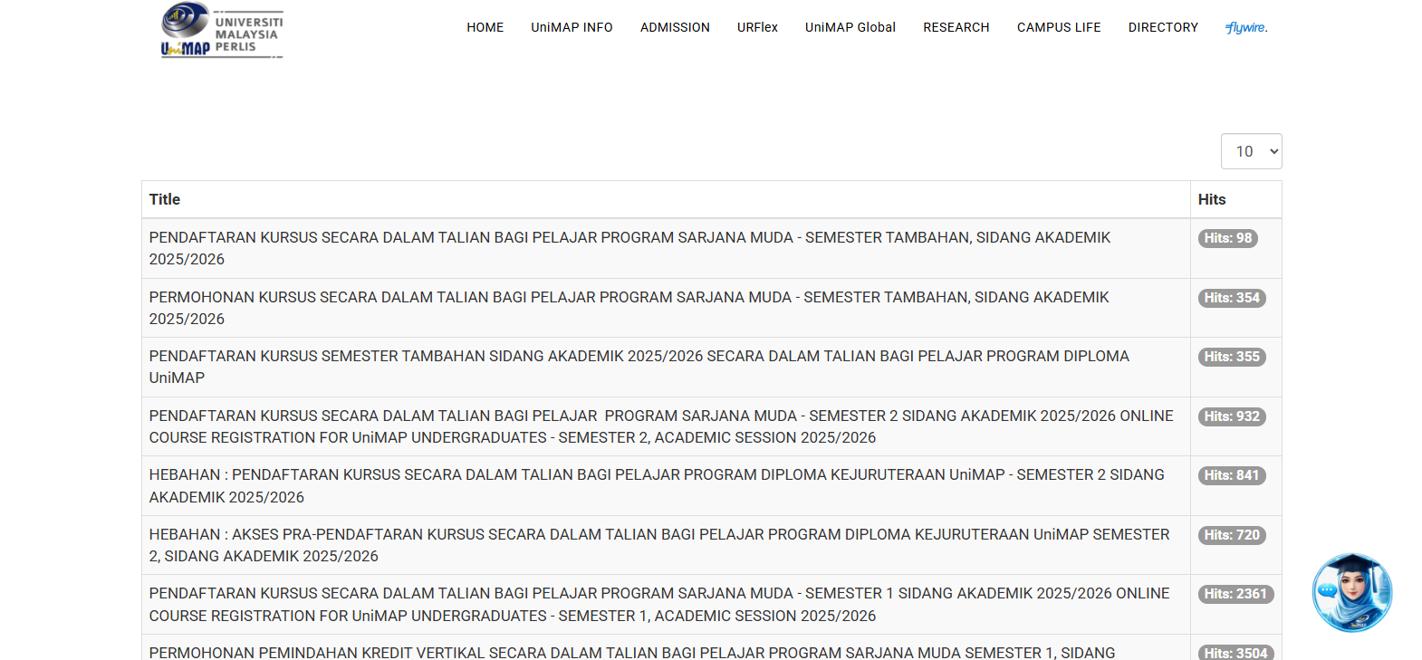

MMU Press
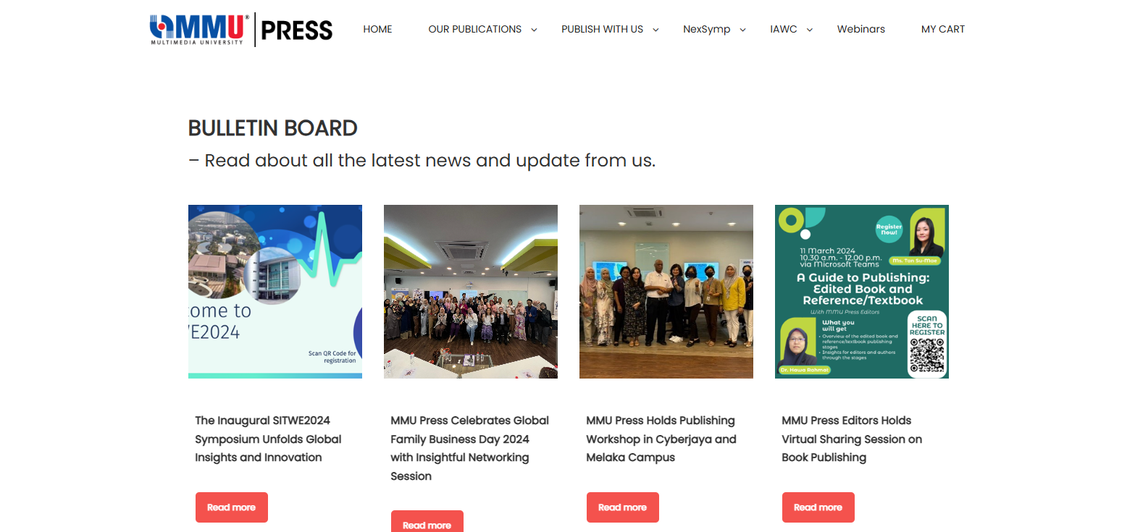

Sunway University eBulletin



Requirement Elicitation
To bridge the gap between clinical administration and student needs, the system requires a framework that addresses accessibility and management efficiency.

User Experience (UX): The platform must offer a smart, user-friendly interface that allows students to make informed decisions regarding services and wellness.

Administrative Control: PKU staff require an authenticated management system to publish, edit, and categorize announcements without manual labour across multiple inconsistent channels.

Responsiveness: Given the mobile-first nature of university students, the application must be cross-platform and compatible with modern web browsers on various devices.

Comparison Among Existing Systems
Digital bulletin boards offer several advantages over traditional physical or static digital methods. Key comparisons include:
System | Strengths | Weaknesses
UNIMAP Bulletin Board | - Views count  - Dense and compact information delivery | - Not mobile friendly  - Looks cluttered
MMU Press | - Aesthetically Pleasing  - Easy to navigate | - Not mobile friendly
Sunway eBulletin | - Very simple to use | - Not mobile friendly  - Lack further information
Proposed NewsNow PKU | - Mobile-friendly  - Realtime Updates  - Intuitive User Interfaces | - No native mobile app
Table 2.4 Comparison among existing system

Information Accessibility: Unlike physical boards, digital platforms allow for real-time updates and remote access to vaccination schedules and clinic hours.

Searchability: Digital systems provide filtering and search functions for specific health topics, such as mental health or immunization, which are impossible with physical posters.

Administrative Efficiency: Automated management through a dedicated dashboard reduces the administrative burden on PKU staff by providing a single point of truth for all official announcements.

Summary
The transition from manual, physical communication to a centralized digital framework like the NewsNow PKU Bulletin Board is essential for modernizing health services at UMPSA. By leveraging technologies such as HTML, React JS, and Tailwind CSS, the project aims to create a responsive environment that improves health literacy and ensures timely information transfer for both students and staff.

METHODOLOGY

Introduction
The methodology chapter outlines the systematic approach adopted to design, develop, implement, and evaluate the “NewsNow” Interactive PKU Bulletin Board web application. This project follows a structured software development lifecycle to ensure that each phase of development is carried out in an organized and efficient manner. The methodology serves as a guideline for transforming the identified communication challenges within the university's health service environment into a practical digital solution. Through a series of planned activities, including requirement analysis, system design, development, testing, and evaluation, the project aims to create a reliable platform that enhances information dissemination between PKU staff and students.
The development of the system utilizes modern web technologies, including HTML, React JS, and Tailwind CSS, which collectively provide a robust foundation for building an interactive, responsive, and user-friendly application. React JS is employed to create dynamic user interfaces and improve application performance, while Tailwind CSS enables efficient and consistent styling across different devices and screen sizes. The selected technology stack supports cross-platform accessibility, ensuring that users can conveniently access the system through various web browsers and devices without compromising functionality or user experience.
In addition, the methodology emphasizes security, usability, and maintainability throughout the development process. Authenticated PKU staff are provided with administrative capabilities to create, update, and manage announcements, health campaigns, and clinic-related information through a centralized content management interface. At the same time, students are granted seamless access to important health notices, event updates, clinic services, and educational resources through an intuitive bulletin board platform. By following this structured methodology, the project seeks to deliver a sustainable and effective communication system that improves information accessibility, reduces dependence on traditional notice boards, and supports the digital transformation initiatives of the university community.

Software Development Life Cycle (SDLC)
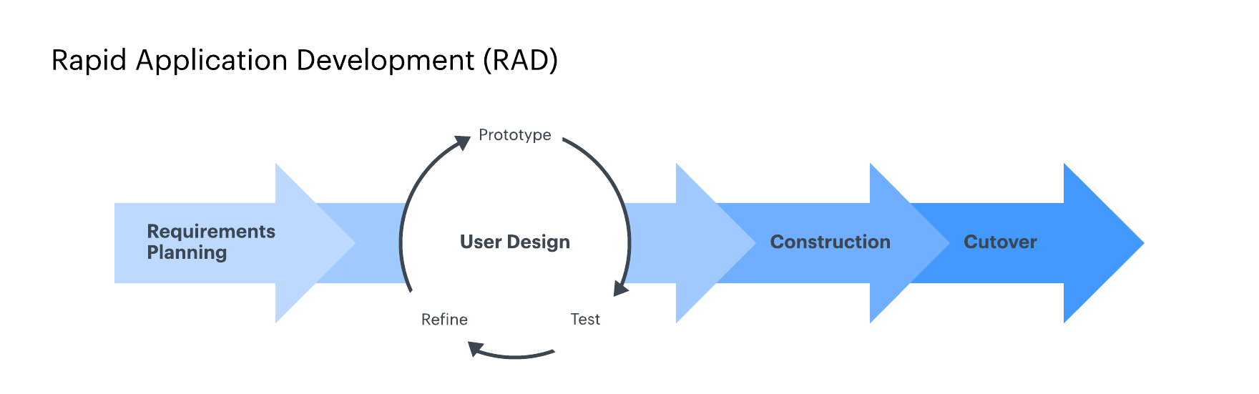
Figure 3.2 RAD

The development of the NewsNow Interactive PKU Bulletin Board follows a Rapid Application Development (RAD) methodology, an adaptive and iterative variant of the traditional Software Development Life Cycle (SDLC). RAD emphasizes accelerated delivery through modular prototyping, continuous user involvement, and flexible response to evolving requirements. The process is structured into four key phases: Requirements Planning, where initial needs are gathered from PKU staff and students; User Design, where interactive prototypes are developed and refined through repeated feedback sessions; Rapid Construction, where the system is incrementally built using a stack of HTML, CSS and JavaScript, with each module being developed, tested, and reviewed in short cycles; and Cutover, which includes final testing, deployment, and user training. This approach ensures that the system remains closely aligned with user expectations, reduces development risks, and enables timely delivery within the constraints of the academic project timeline, while still maintaining a structured pathway from conception to deployment.

Advantages | Disadvantages
- Allows for speedy development  - High adaptability and flexibility  - Active involvement of users allows for an accurate model of the prototype  - Reduced overall development costs. | - Requires user input at numerous stages  - Limited scalability for very large, tightly coupled systems

Table 1.1 RAD Advantages

Project Requirement

Functional Requirement

The system shall allow PKU staff to log in securely to a dedicated admin panel.

The system shall allow authenticated staff to create, edit, publish, and delete bulletin posts.

The system shall display bulletin to students in a structured format.

The system shall be accessible via web browsers on both desktop and mobile devices without loss of functionality.

The system shall allow students to filter bulletin posts by categories

The system shall notify PKU staff via email or dashboard alert when a new announcement is successfully published or edited.

The system shall support file uploads (e.g. images) within bulletin posts for attached resources.

The system shall provide role-based access control to ensure only authorized staff can manage content.

Non-Functional Requirement

The system shall load pages within 3 seconds under normal network conditions.

The system shall be responsive and usable on screen sizes ranging from mobile phones to desktop monitors.

The system shall maintain data consistency and prevent unauthorized access through secure authentication mechanisms.

The system shall be available at least 95% of the time during operational hours.

The system shall comply with basic accessibility standards (e.g., readable fonts, contrast ratios, keyboard navigation support).

The system shall support at least 100 concurrent users without performance degradation.

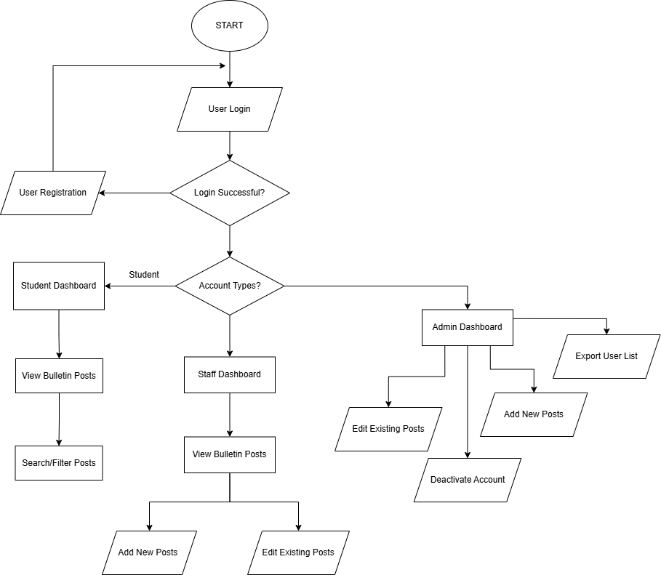
General Flow Chart

Figure 3.33 Flowchart

General Use Case Diagram
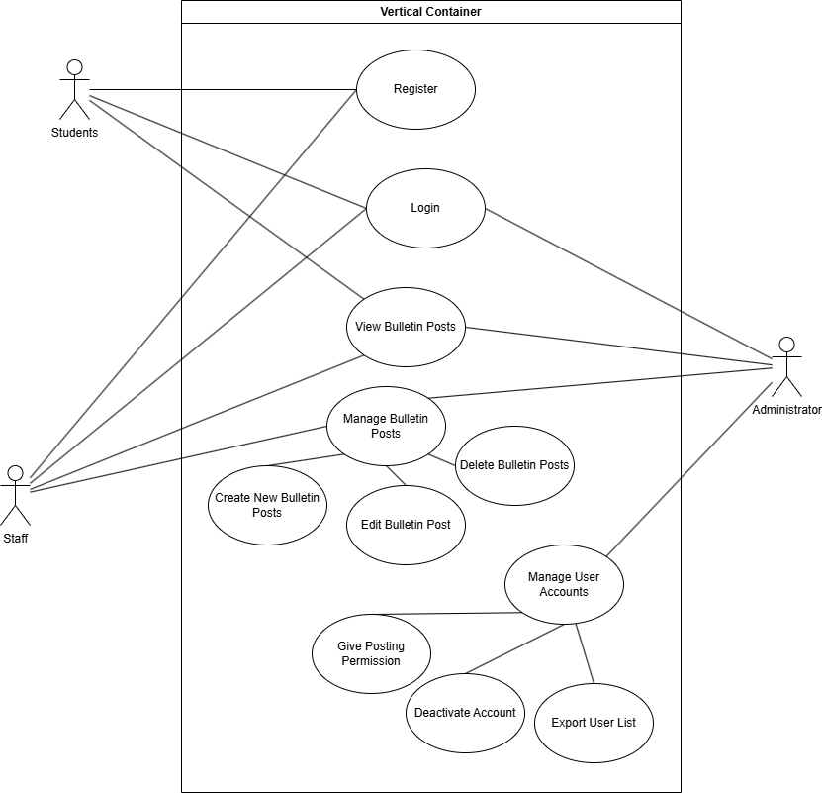
Figure 3.3.4 Use Case Diagram

Context Diagram (DFD Level 0)
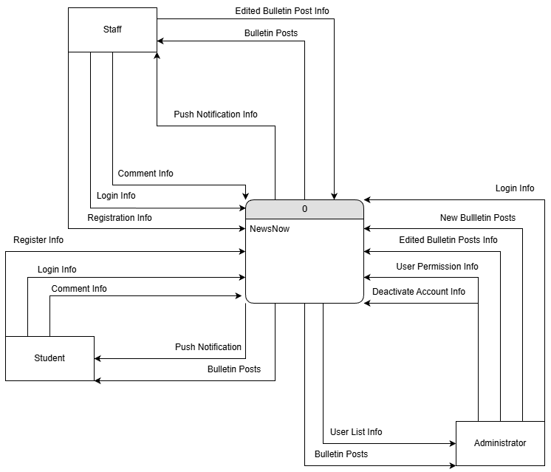

Figure 3.3.5 Context Diagram

DFD Level 1
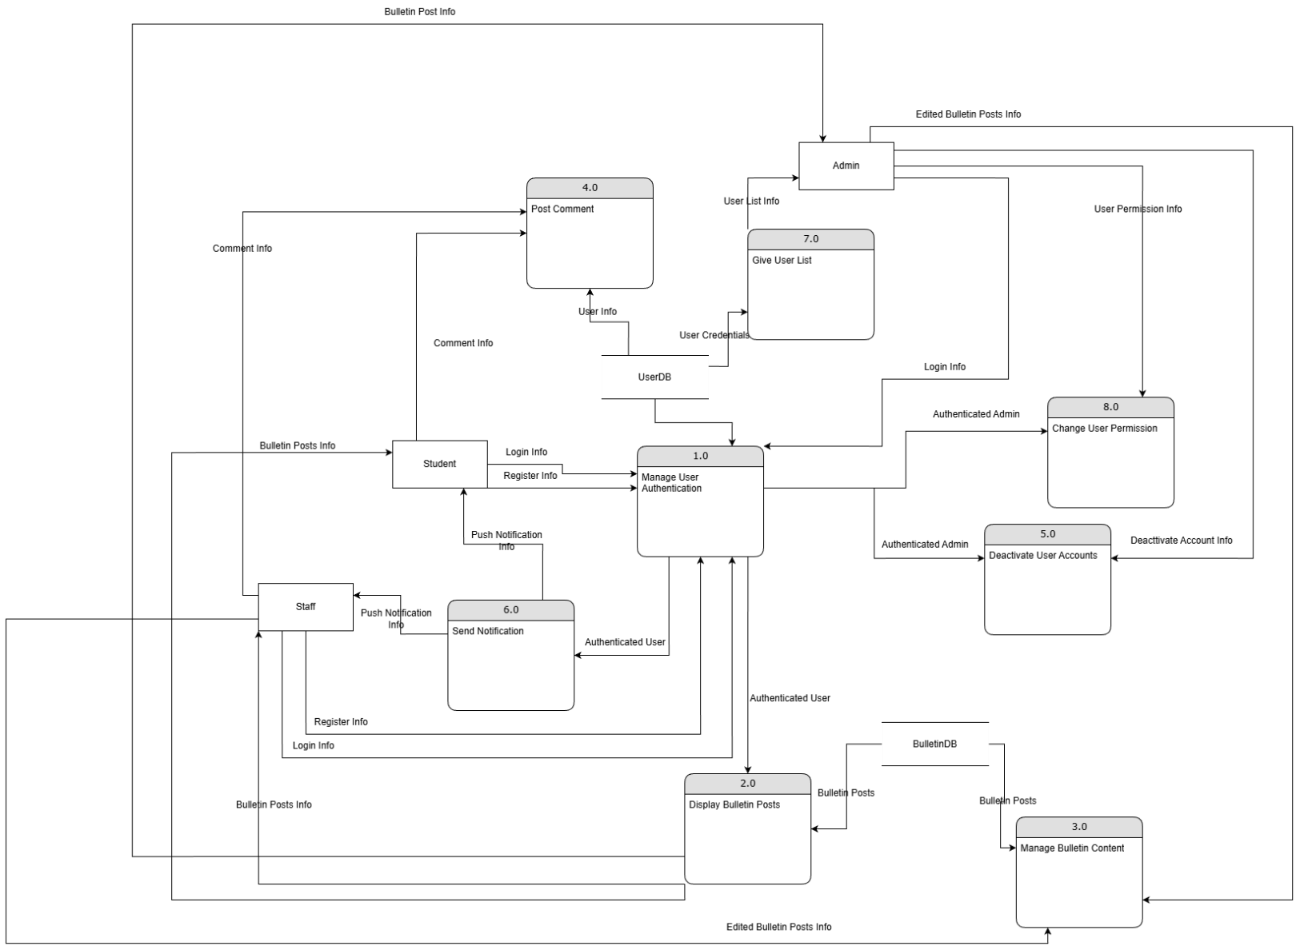

Figure 3.3.6 DFD Level 1

User Requirements

Interview with PKU Staffs
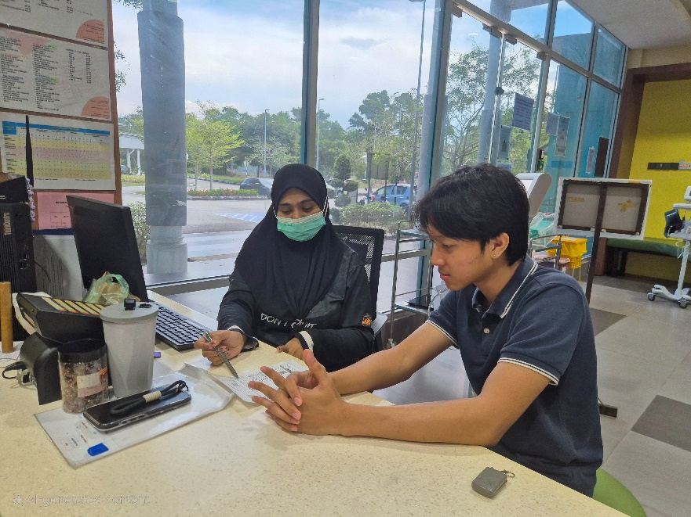
Figure 3.4.11 Interviewing PKU Staff 1

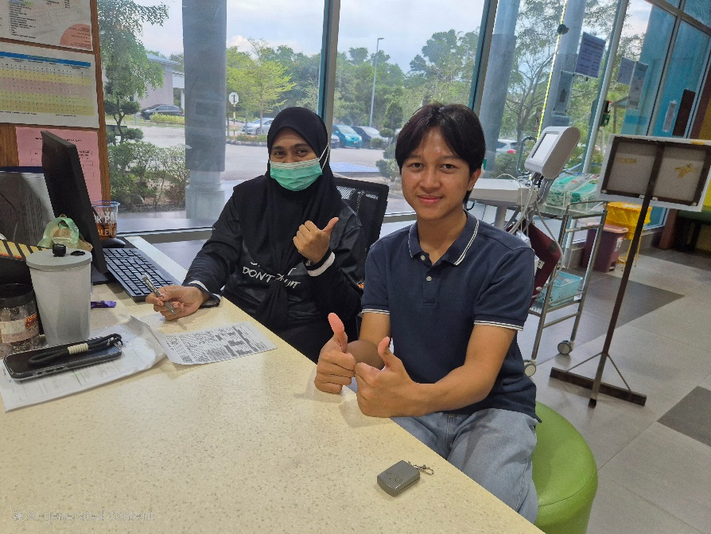
Figure 3.4.12 Finish Interviewing PKU Staff 1


Figure 3.4.13 Interviewing PKU Staff 2

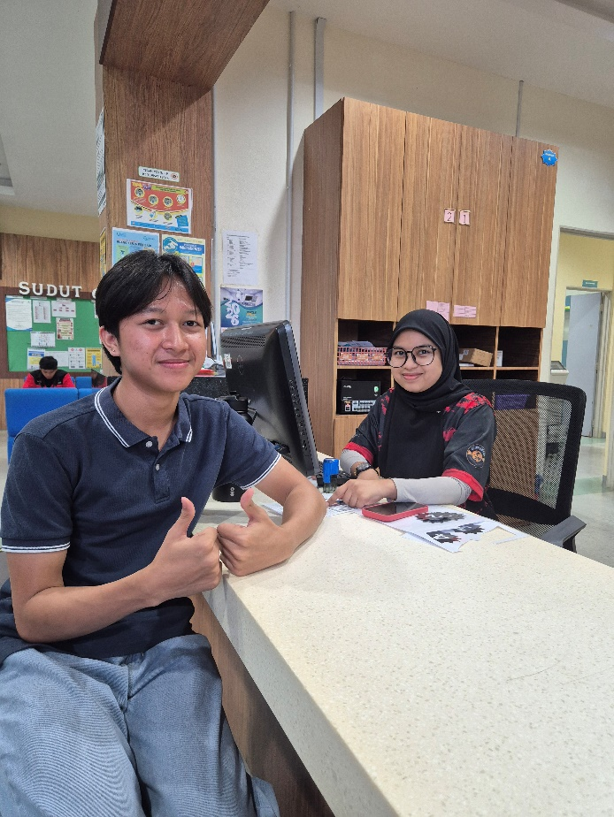
Figure 3.4.14 Finished Interviewing PKU Staff 2

Proposed Design

Class Diagram
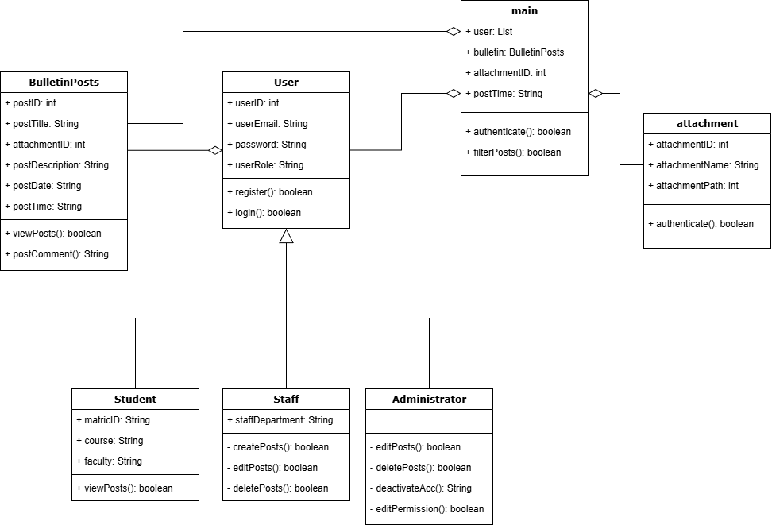
Figure 3.5.1 Class Diagram

Data Design

ERD
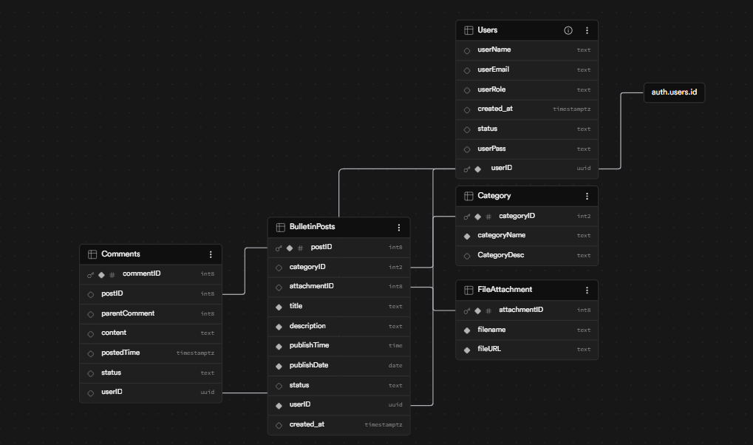
Figure 3.6.1 Entity Relationship Diagram

Proof of Concepts
Screen Title: | Auth Page
Layout: | 01
Link From Screen: | None
Link To Screen: | Dashboard
Screen Layout: | 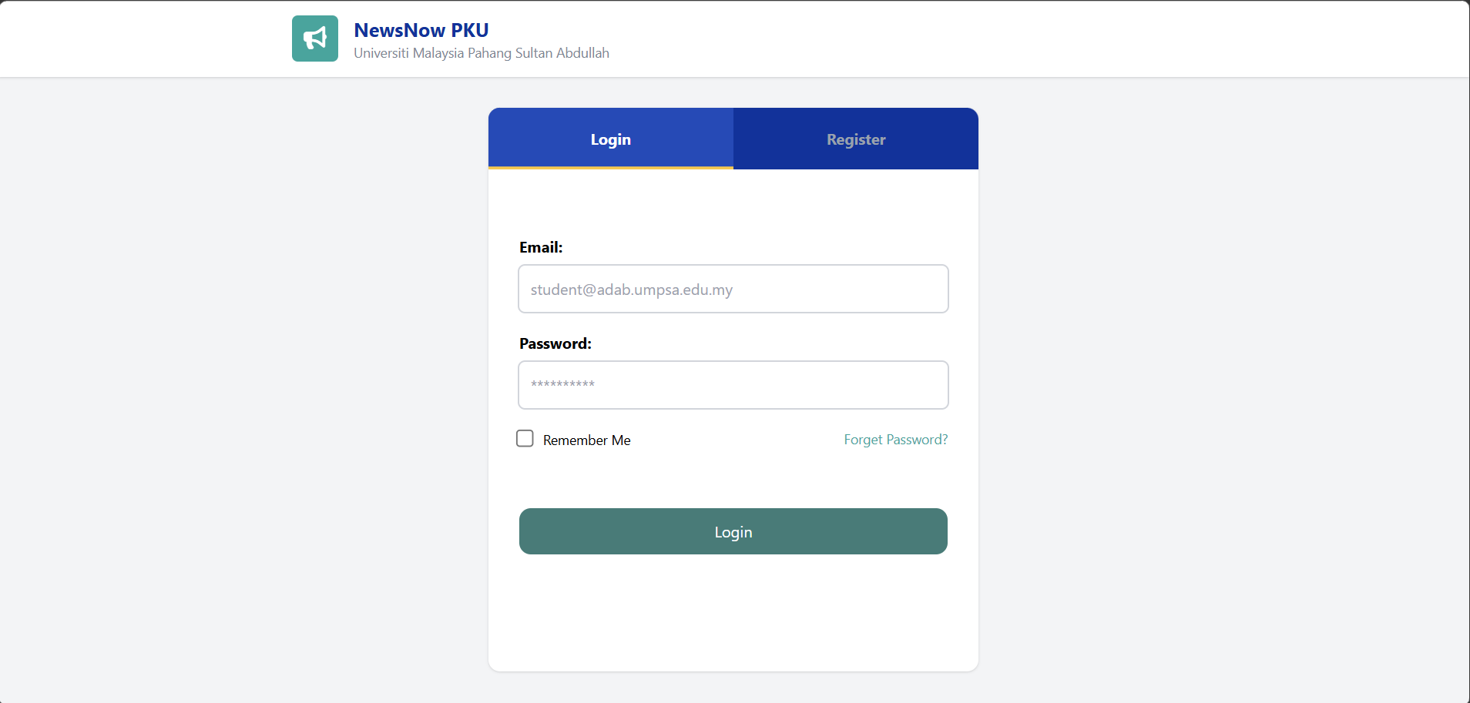
Description: | The Authentication Page
Multimedia Element: | Images, Button, Navigation Bar

Screen Title: | Register Page
Layout: | 01
Link From Screen: | None
Link To Screen: | Login
Screen Layout: | 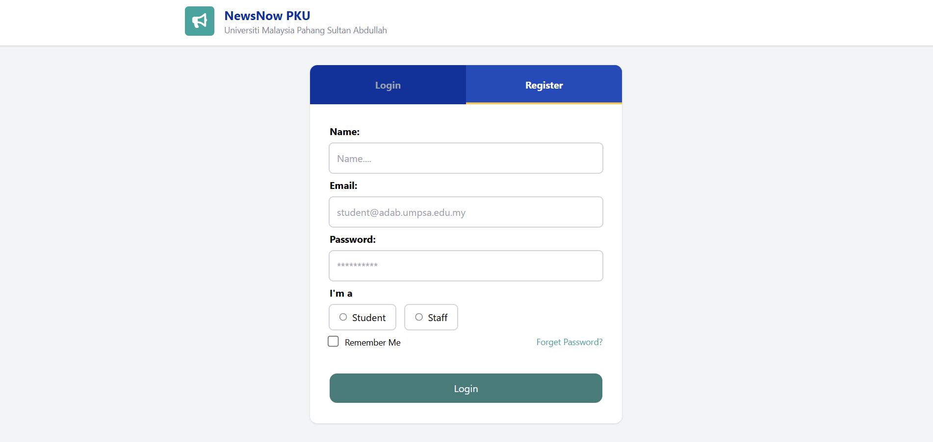
Description: | The Register Page
Multimedia Element: | Images, Button, Navigation Bar

Screen Title: | Dashboard Page
Layout: | 02
Link From Screen: | Login
Link To Screen: | Dashboard
Screen Layout: | 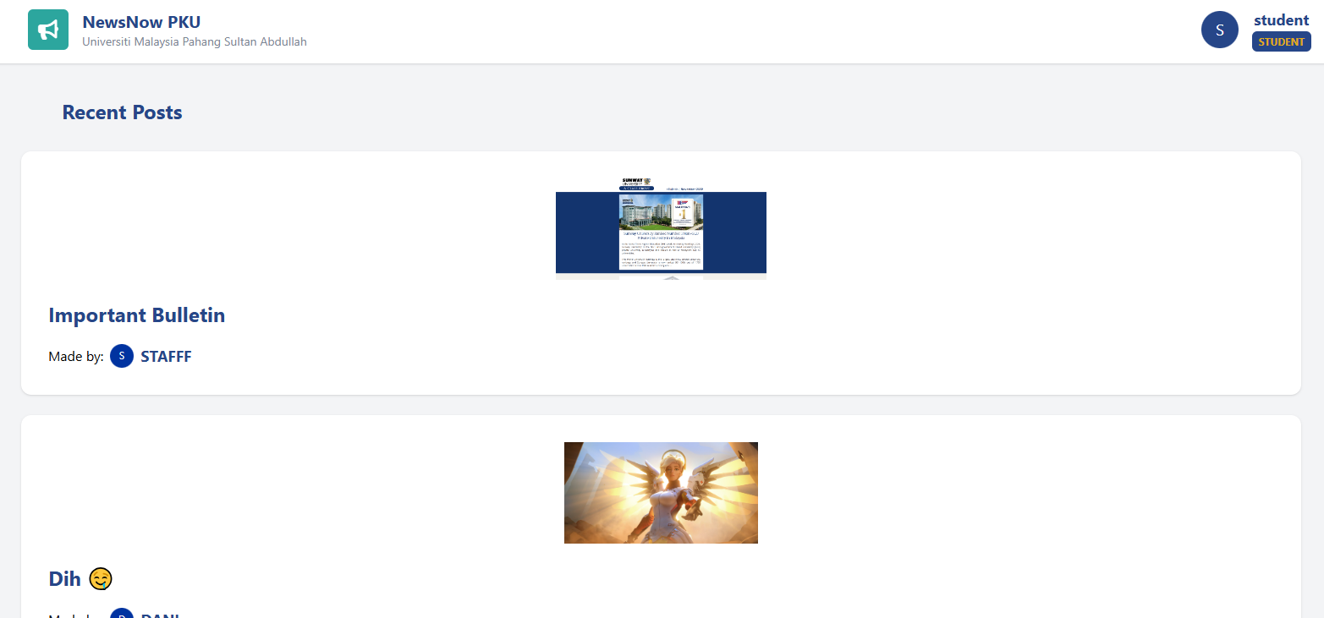
Description: | The main page (dashboard) after the user logs in
Multimedia Element: | Images, Button, Navigation Bar

Screen Title: | Staff Dashboard
Layout: | 03
Link From Screen: | Login Page
Link To Screen: | Staff Dashboard
Screen Layout: | 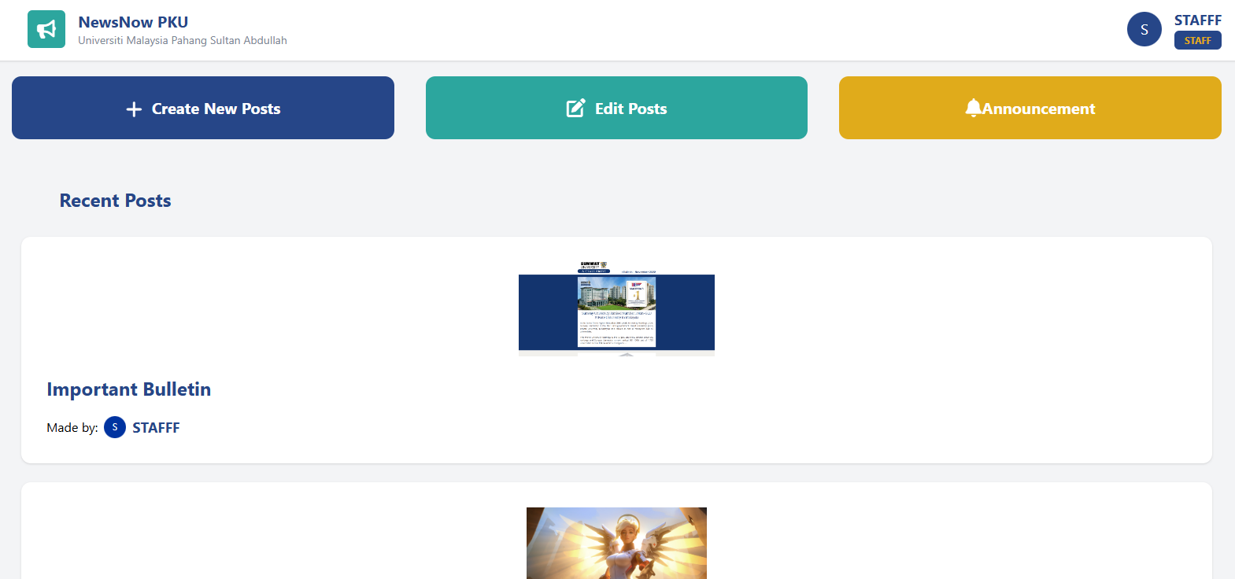
Description: | The staff home page
Multimedia Element: | Images, Button, Navigation Bar

Screen Title: | Admin Dashboard
Layout: | 03
Link From Screen: | Login Page
Link To Screen: | Admin Dashboard
Screen Layout: | 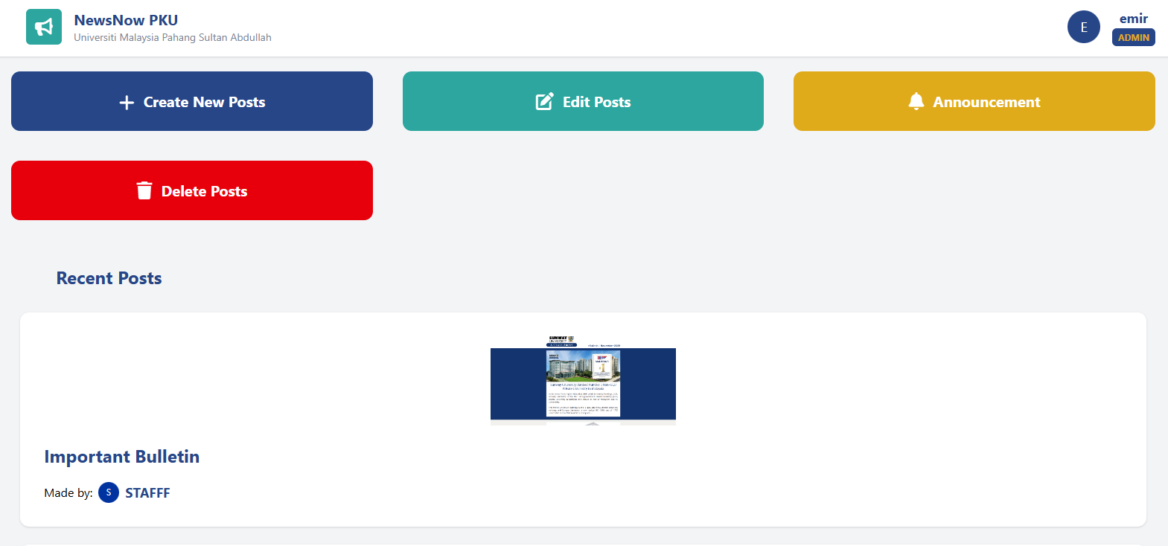
Description: | The Admin Dashboard
Multimedia Element: | Images, Button, Navigation Bar

Screen Title: | Create Post
Layout: | 03
Link From Screen: | Staff Dashboard
Link To Screen: | Create Post
Screen Layout: | 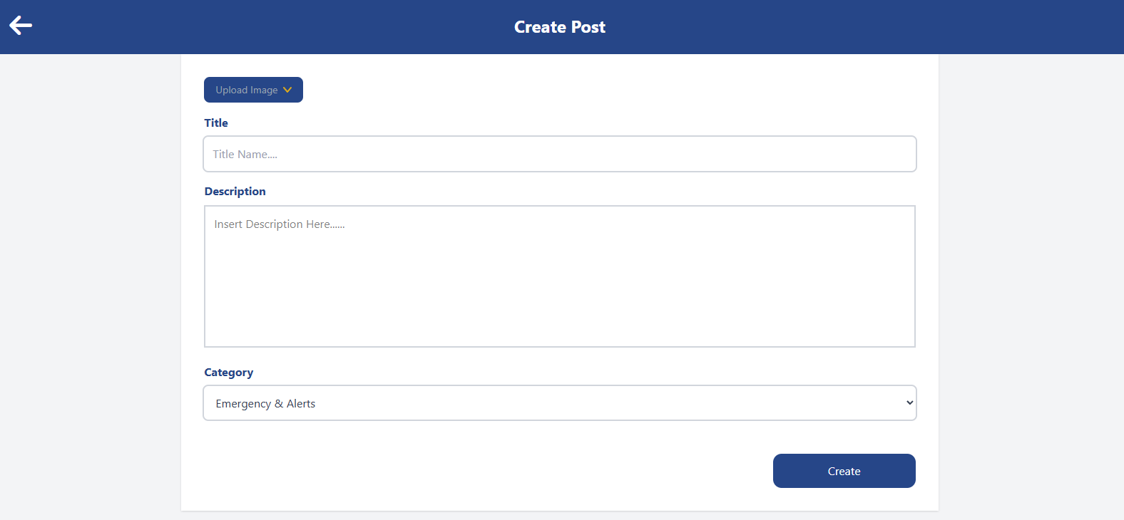
Description: | The staff home page
Multimedia Element: | Images, Button, Navigation Bar

Screen Title: | Edit Posts
Layout: | 03
Link From Screen: | Login Page
Link To Screen: | Staff Dashboard
Screen Layout: | 
Description: | The staff edit posts page
Multimedia Element: | Images, Button, Navigation Bar

Screen Title: | Make Announcement Page
Layout: | 03
Link From Screen: | Staff Dashboard
Link To Screen: | Make Announcement
Screen Layout: | 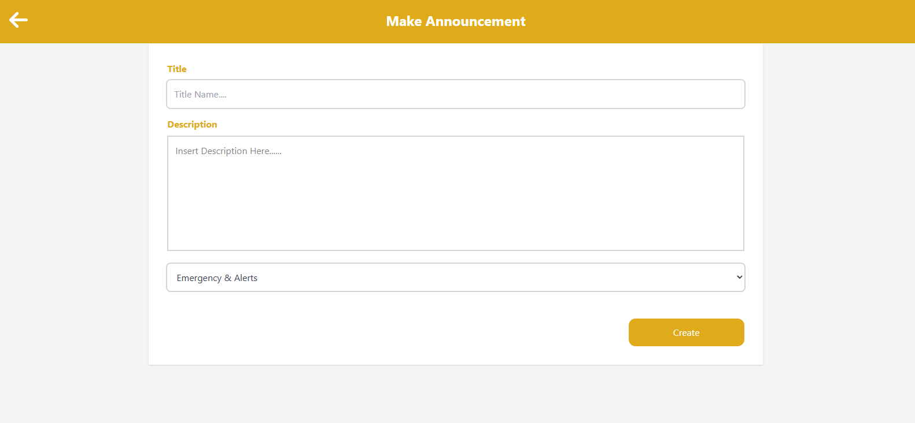
Description: | The staff home page
Multimedia Element: | Images, Button, Navigation Bar

Testing Plan

Test | Status | Feedback
General
Login | Pass/Fail
Register | Pass/Fail
Logout | Pass/Fail
Student Dashboard
View Posts | Pass/Fail
Post Comment | Pass/Fail
Staff Dashboard
Create New Post | Pass/Fail
Edit Posts | Pass/Fail
Delete Posts | Pass/Fail
View Post | Pass/Fail
Administrator Dashboard
Export User List | Pass/Fail
Deactivate Account | Pass/Fail

Gantt Chart
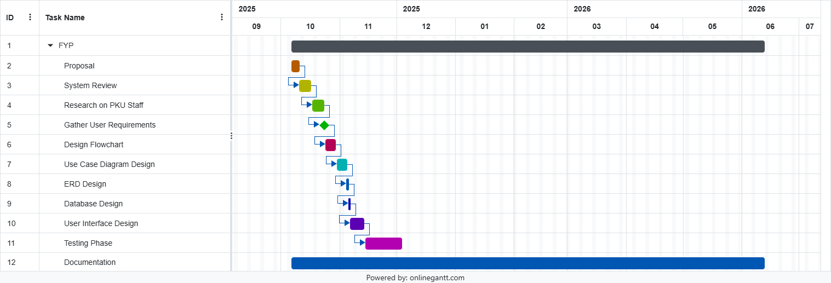
Figure 3.9 Gantt Chart

RESULTS AND DISCUSSION

Introduction
This chapter presents the evaluation results and empirical findings of the developed Interactive PKU Bulletin Board system, known as “NewsNow”. The primary goal of this evaluation was to analyze if the developed web platform meets the required system standards, specifically focusing on information accessibility, administrative efficiency, and cross-platform responsiveness. To validate the performance and user satisfaction of the system, a comprehensive User Acceptance Testing (UAT) session and a comparative evaluation survey were executed with thirty-four ($N=34$) target university respondents.

Presentation of Results
This section illustrates the quantitative data gathered from the target respondents. The collected data is structurally categorized into primary evaluation layers: the demographic profile of the participants, functional verification under Research Objective 2, and a comparative tool evaluation contrasting NewsNow against traditional university health communication channels.

Demographic Profile of Respondents
The survey captured responses from a diverse mix of university youth to ensure a well-rounded assessment of the user interface.
- Academic Distribution: Out of the 34 total participants, 58.8% ($n=20$) were Diploma students, and 41.2% ($n=14$) were Degree students.
- Institutional Representation: The peer network primarily comprised students and staff from the local university ecosystem, ensuring the testing was conducted by actual stakeholders of the campus environment.

Core System Performance Evaluation
A 5-point Likert scale (ranging from 1 = Strongly Disagree to 5 = Strongly Agree) was utilized to measure system performance indicators.
The system's capacity to instantaneously broadcast health notices and emergency announcements without database lagging was evaluated.
Likert Rating | Response Percentage (%) | Respondent Count (n)
5 (Strongly Agree) | 52.9% | $n = 18$
4 (Agree) | 20.6% | $n = 7$
3 (Neutral) | 11.8% | $n = 4$
2 (Disagree) | 11.8% | $n = 4$
1 (Strongly Disagree) | 2.9% | $n = 1$
Result Summary: The real-time synchronization of the bulletin board achieved highly positive feedback, yielding a high mean score of 4.15. This validates that the integration of the reactive frontend with the database architecture functions accurately and without processing delays.

Discussion
The empirical data collected from the UAT survey confirms that all three primary project objectives have been successfully accomplished. Investigating stakeholder requirements highlighted that information fragmentation across unofficial social media streams severely limits health awareness on campus. NewsNow addresses this vulnerability by centralizing announcements into a single point of truth. From an educational and operational perspective, translating clinical updates—such as mental health resources, clinic operational changes, and immunization drives—into dynamic content slots successfully bridges the communication gap between healthcare providers and students. The high performance recorded during user testing strongly aligns with established interactive system literature, validating that user-friendly digital layouts foster significantly better comprehension and responsiveness than static text displays. However, an operational limitation was observed within the system architecture during evaluation. The current content posting module limits category assignments to a strict, pre-defined selection. While this structure protects database alignment and prevents index fragmentation within the backend, it restricts administrators from generating customized sub-categories for unique, temporary public health campaigns.

Conclusion
In conclusion, this chapter presented the empirical quantitative testing data and associated discussion for the “NewsNow” Interactive PKU Bulletin Board system. The usability metrics fall squarely into the "very good" and "excellent" ranges, demonstrating that the user interface allows students to browse notices easily while empowering staff to manage records efficiently. Operationally, pre-test evaluations and post-test feedback indicated a substantial improvement in user information accessibility and health literacy. These positive findings prove the baseline efficacy of the software framework and establish a reliable foundation for the final conclusions and future architectural recommendations detailed in Chapter 5.

General
Feature | Expected Result | Actual Result | Status
Login | User can log in using valid credentials | Pending | Pass
Logout | User is logged out and session is cleared | Pending | Pass
Register | User can create a new account | Pending | Pass
Table 4.21

Student Dashboard
Feature | Expected Result | Actual Result | Status
View Posts | View all active posts | Pending | Pass
Post Comment | Post Comments | Pending | Pass
Table 4.22

Staff Dashboard
Feature | Expected Result | Actual Result | Status
Create New Posts | Create a new visible post | Pending | Pass
View Posts | View all active posts | Pending | Pass
Delete Posts | Delete posts | Pending | Pass
Edit Posts | Edit posted Posts | Pending | Pass
Table 4.23

CONCLUSION

Introduction
The development of the NewsNow Interactive PKU Bulletin Board successfully achieved the objectives outlined at the beginning of this project. The system was designed and developed to address the communication challenges faced by the University Health Centre (PKU) in disseminating health-related information, announcements, and clinic services to students. Through the implementation of a centralized web-based platform, the project provides a more efficient and accessible alternative to traditional communication methods such as physical bulletin boards and scattered social media posts.
The project successfully investigated the requirements of both PKU staff and students, allowing the development of a system that meets the needs of its intended users. By utilizing modern web technologies such as HTML, React JS, and Tailwind CSS, a responsive and user-friendly application was created. The system enables authenticated PKU staff to create, edit, publish, and manage announcements efficiently, while students can easily access, search, and view important health-related information through a centralized platform.
Testing results indicate that the major functionalities of the system, including user registration, login, logout, post management, and announcement viewing, were successfully implemented and operated as expected. The responsive design also ensures accessibility across various devices, supporting both desktop and mobile users. These outcomes demonstrate that the system is capable of improving information visibility, reducing communication barriers, and enhancing the overall effectiveness of health information dissemination within the university community.
Despite the successful implementation of the core features, several limitations remain. The current version focuses primarily on bulletin management and basic user interactions. Future enhancements may include real-time notifications, appointment booking integration, advanced analytics, personalized content recommendations, and stronger security features to further improve user experience and system effectiveness.
In conclusion, the NewsNow Interactive PKU Bulletin Board provides a practical and effective solution for modernizing communication between PKU and the UMPSA community. The project contributes towards the university's digital transformation efforts by delivering a centralized, accessible, and efficient platform that promotes health awareness and supports the dissemination of timely information to students and staffs.

Summary of the Research
The core focus of this research was to design, implement, and evaluate an online bulletin board platform for the University Health Centre (PKU) to address the persistent challenges of fragmented health information dissemination and low notice visibility among university students. Traditional campus notification channels frequently rely on physical notice boards, irregular social media updates, or deeply nested web pages, which often fail to actively engage mobile-oriented students or deliver critical health updates timely. To resolve this operational gap, an interactive digital bulletin application was engineered utilizing a frontend architecture built on HTML, React JS, and Tailwind CSS, reinforced by an agile backend data layer. The completed platform successfully simulates a centralized notification center, featuring dedicated content categories, real-time posting components, administrative dashboard operations, and filtering tools. Through structured web layout designs and immediate post validation, the system establishes an efficient and accessible environment where university students can securely consume certified health notices, thereby promoting proactive wellness behaviors across the campus community.

Achievement of Research Objectives
The technical execution of this project successfully fulfilled all three core research objectives established at the initiation of the study:
- Objective 1: To investigate and document the specific needs of PKU staff and students regarding centralized health announcement features. Accomplished by conducting structured user requirement gathering sessions and clinical staff interviews. The empirical data collected directly informed the core functional design, identifying critical tracking requirements such as real-time updates and search capabilities.
- Objective 2: To design and develop a user-friendly, cross-platform web application for a PKU Health Bulletin Board. Achieved through the implementation of a responsive, role-based web architecture using React JS and Tailwind CSS. The platform successfully translates administrative workflows into responsive interface components, allowing validated staff to publish updates securely while ensuring visual layout stability across desktop and mobile form factors.
- Objective 3: To evaluate the NewsNow Web App to ensure it is effective in delivering timely information and enhancing user accessibility. Validated by conducting a comparative User Acceptance Testing (UAT) survey with thirty-four (N=34) target university respondents. The developed platform systematically outperformed traditional communication methods across all measured usability parameters, securing an overall recommendation mean score of 3.88.

Contributions to the study
This research delivers two distinct values to the academic and operational environment:
- Practical Contribution which provides the university health center and the campus community with an optimized, centralized, and entirely risk-free digital environment to access up-to-date health directives, scheduling changes, and emergency alerts, directly increasing public health literacy.
- Technical Contribution which offers a verified web engineering design model demonstrating how lightweight frontend frameworks, combined with modern CSS utilities, can maintain high cross-platform performance and UI clarity while eliminating visual clutter for end-users.

Limitations of the study
Despite fulfilling its structural design goals, two primary limitations were identified during the development and testing phases:
- Functional Rigidity: The current posting architecture restricts categorization to fixed binary or pre-determined labels, which prevents administrative staff from adjusting metadata structures or deploying highly customized tags for unexpected public health events.
- Sample Localization: The User Acceptance Testing evaluation was confined to a sample size of thirty-four ($N=34$) university participants. While statistically useful for baseline testing, this localized group does not fully reflect the diverse user behaviors and accessibility requirements of the broader university community across different regions and campuses.

Reccommendations for future work
To maximize the system’s operational performance, feature diversity, and community accessibility, the following future developments are recommended:
- Native Mobile Porting: The existing web framework should be packaged and optimized into standalone mobile applications for Android and iOS platforms to leverage native smartphone features such as push notifications and offline caching.
- Functional Subsystem Integration: The backend should be expanded to incorporate advanced operational capabilities, including real-time appointment booking, automated text alerts, and interactive public health consultation queues.
- Large-Scale Multi-Campus Testing: Future evaluation phases should expand the UAT survey scope to encompass a significantly larger and more geographically diverse user base across multiple university branches, gathering comprehensive data on system scalability and shifting user trends.

Final Conclusion
In conclusion, the developed Interactive PKU Bulletin Board (“NewsNow”) has successfully fulfilled all its research objectives and technical system design standards. The completion of this project demonstrates that combining modular, reactive web interfaces with structured content management design yields a highly effective educational and operational communication channel. By decisively outperforming traditional, fragmented communication methods in user acceptance, this software demonstrates how targeted web-based solutions can modernize information delivery, improve administrative workflows, and actively support the health and well-being of the university community.

REFERENCE
https://www.w3schools.com/REACT/default.asp
https://tailwindcss.com/docs/installation/using-vite
https://react.dev/learn

APPENDICES

